MACH4METAL

metalworking machinery
Transito 21
6909 DA BABBERICH Netherlands
Tel. +31 (0)316-247123
Fax: +31 (0)316-247956
info@mach4metal.com
www.mach4metal.com

Bank No : 66.52.13.883
IBAN : NL33 INGB 0665 2138 83
BIC : INGBNL2A

Guillotine SAFAN HT 3000 x 10 mm

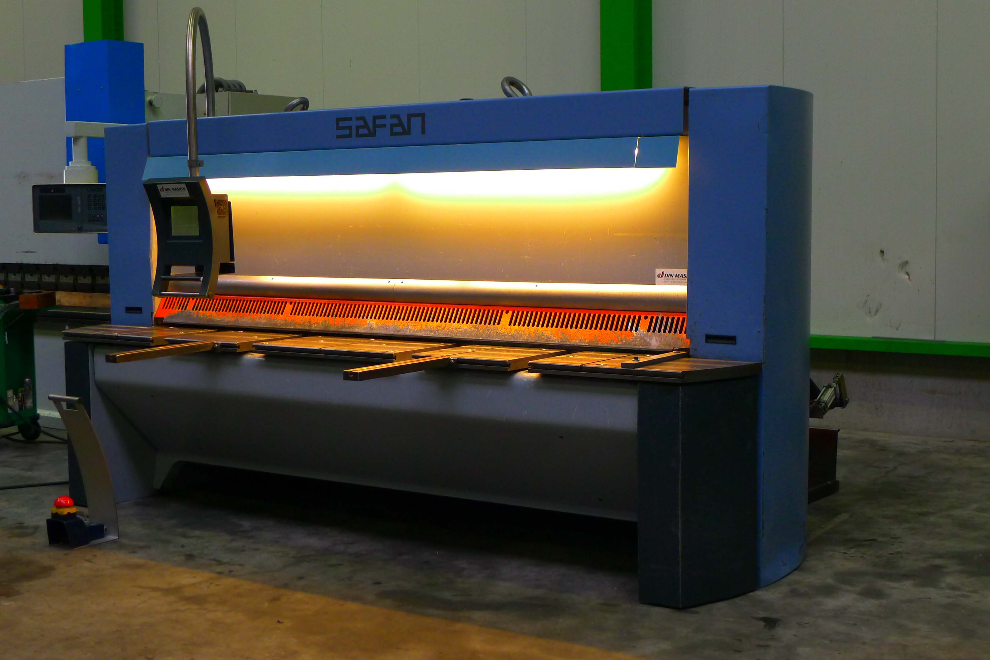
- Make : SAFAN Nederland
- Type : HT 310 / 10
- Mach.No : B 8691
- YOP : 2002

- Max. cutting length : 3.100
- Sheet thickness ST450 : 10 mm

- Stroke’s p/Min. : 30
- Stroke’s p/Min. : 12
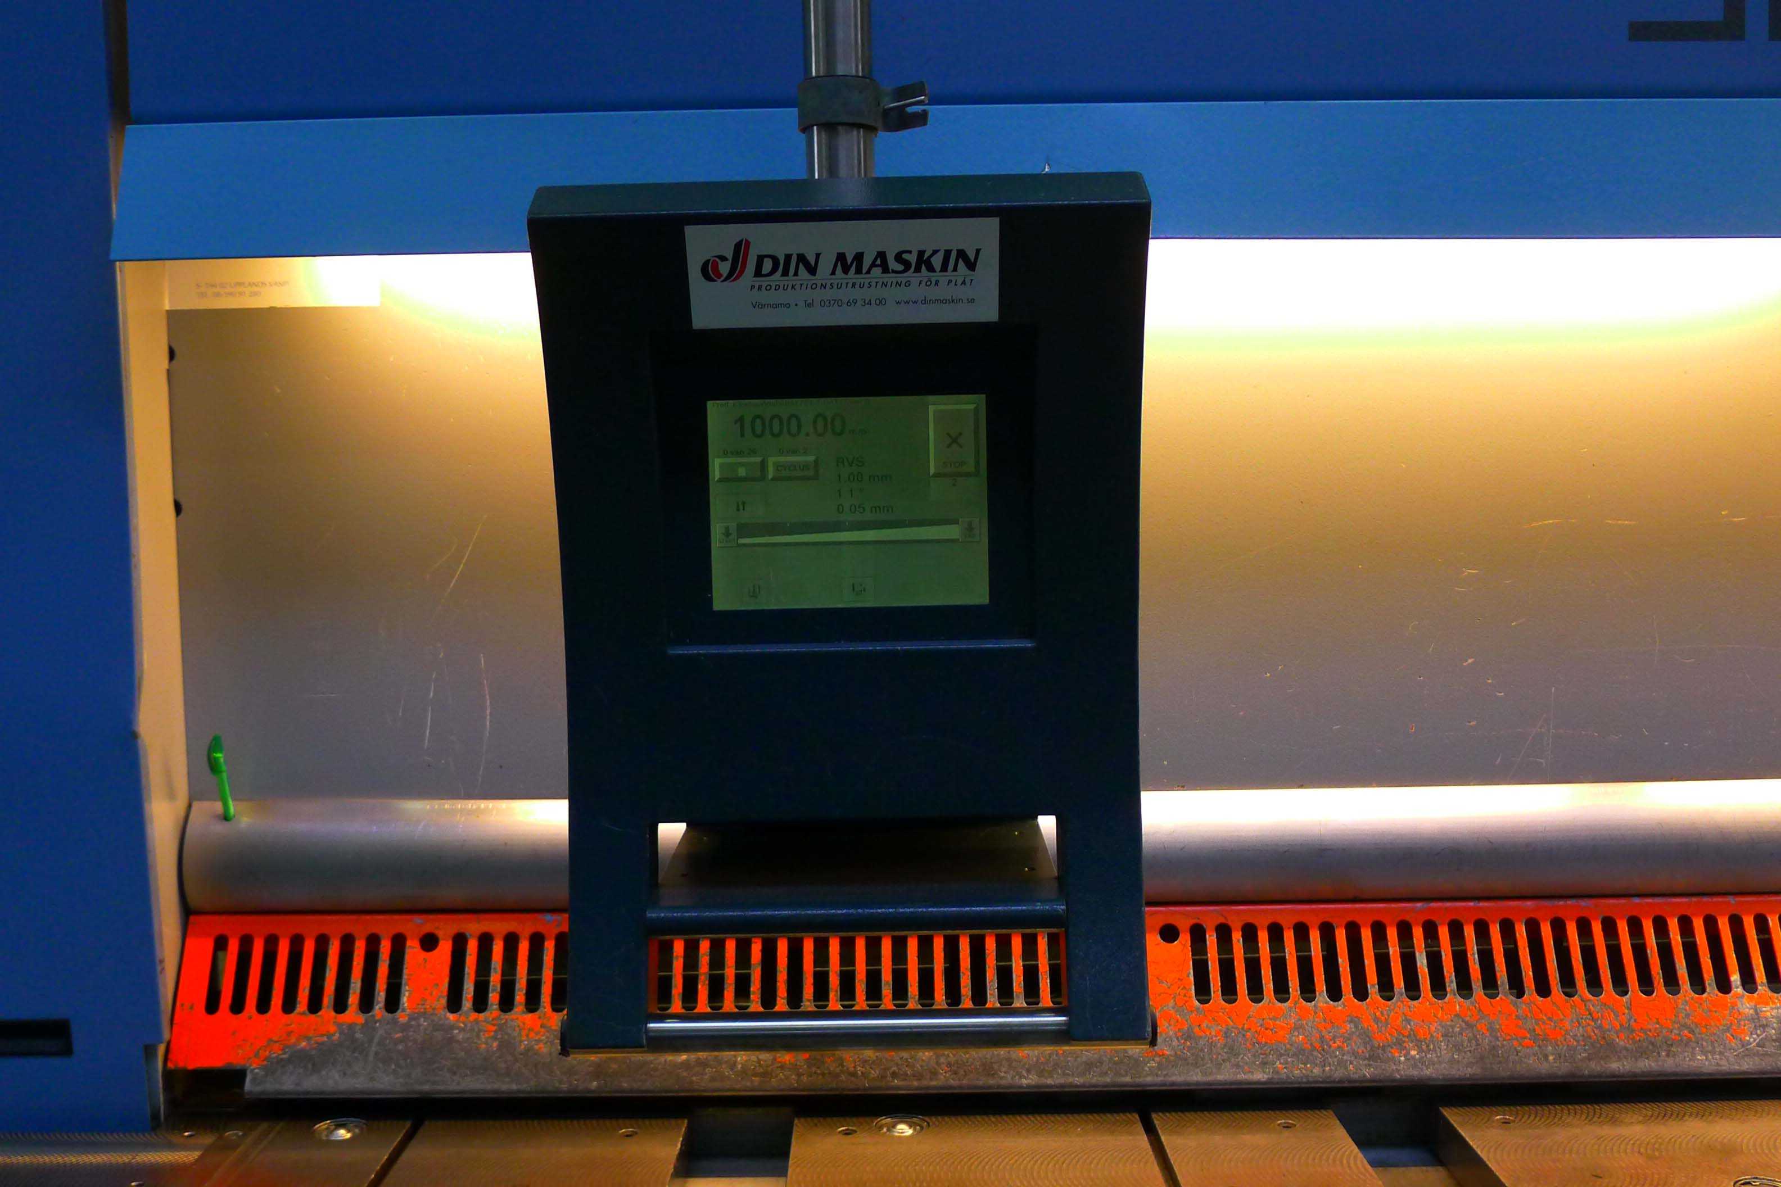

- Working speed : 200 mm/sec
- Working area : 1.000 mm

- Cutting angle min. : 0,5˚
- Cutting angle max. : 2,0˚

- TS 100 Control TOUCHSCREEN
- Sheet support pneumatic back side
- Sick safety guides back side
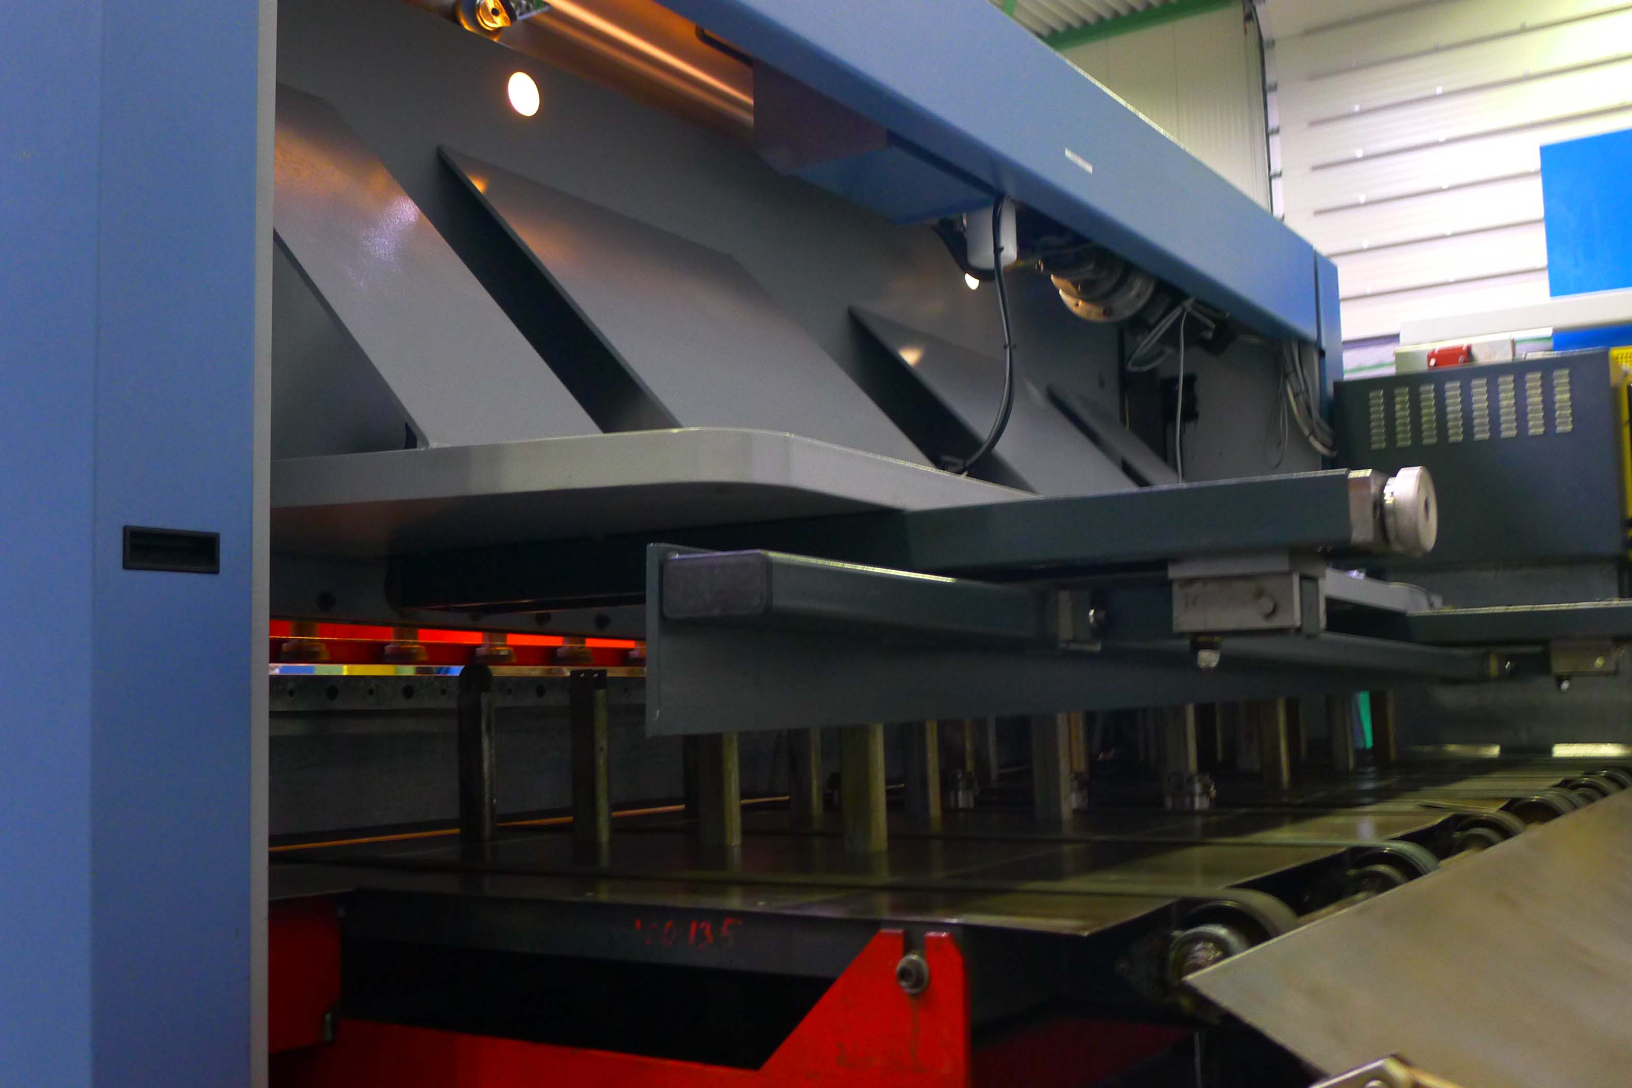
- Front stop L = ca. 3.000 mm

- Dimensions
- Length : 4.050
- Width : 2.300
- Height : 2.150
- Weight : 9.800
- Power : 15 kW

- Excellent condition
- New Euro 80.000 !

Please Note: The above information has been obtained to the best of our ability and belief from, and from the manufacturers where possible. It is given in good faith, but its accuracy can not be guaranteed. Accordingly, it will not form a representation or constitute contractual terms. We advise you to check any vital details!

